Worksheet 02 – Interface design in your first App Answer

Task 1 (10 marks):
You interface design:
Interface "Game" design | Interface "Result" design
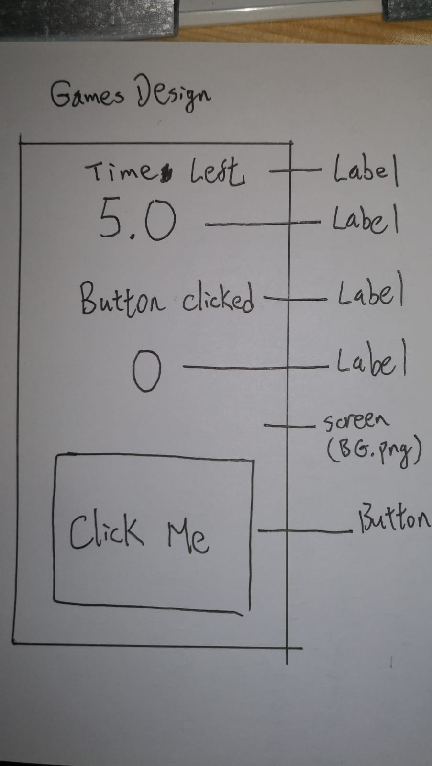 | 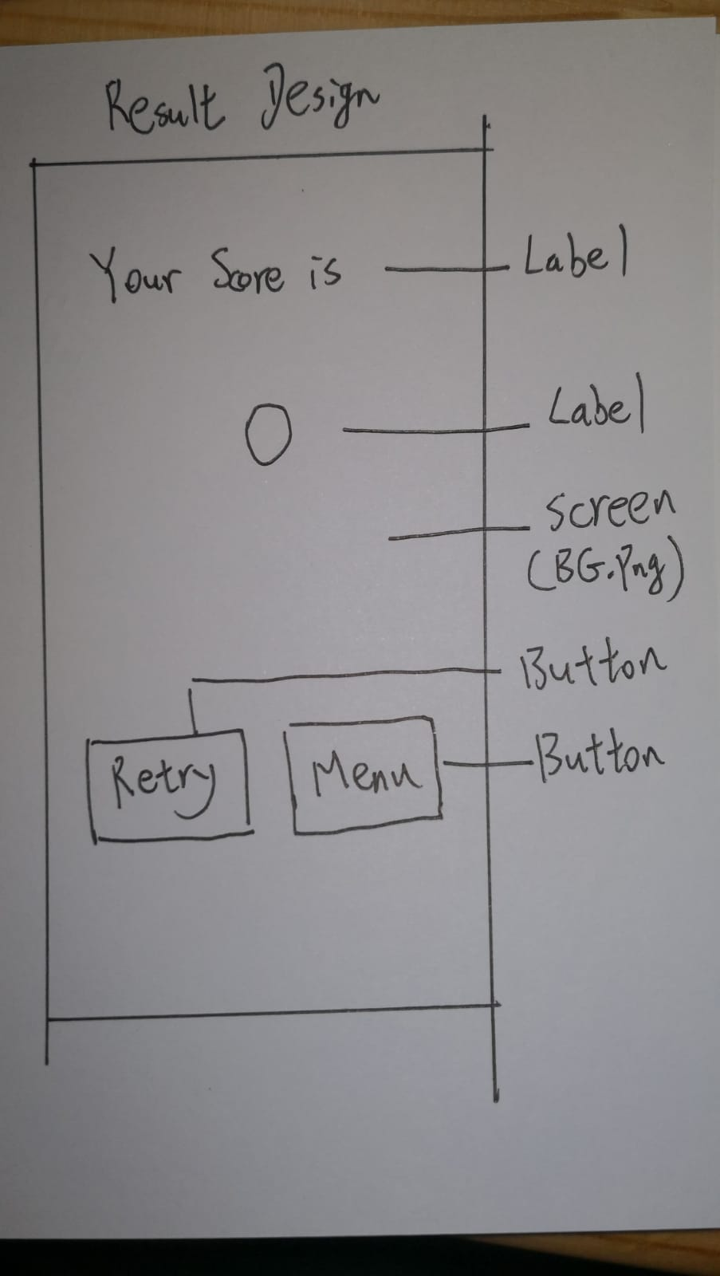

Task 2 (5 marks):
In MIT App Inventor 2, finish the following steps:

Step 1: Start a new project named "BPST_3E01". (Please use your own class and class number)
Step 2: Use "Add Screen…" function to add 2 screens named "Game" and "Result".
Step 3: In every screen, try adding components according to your design in Task 1.
Step 4: Try to edit the "Properties" of every components.
Step 5: Export your project to (.aia), and submit to the Schoology.

